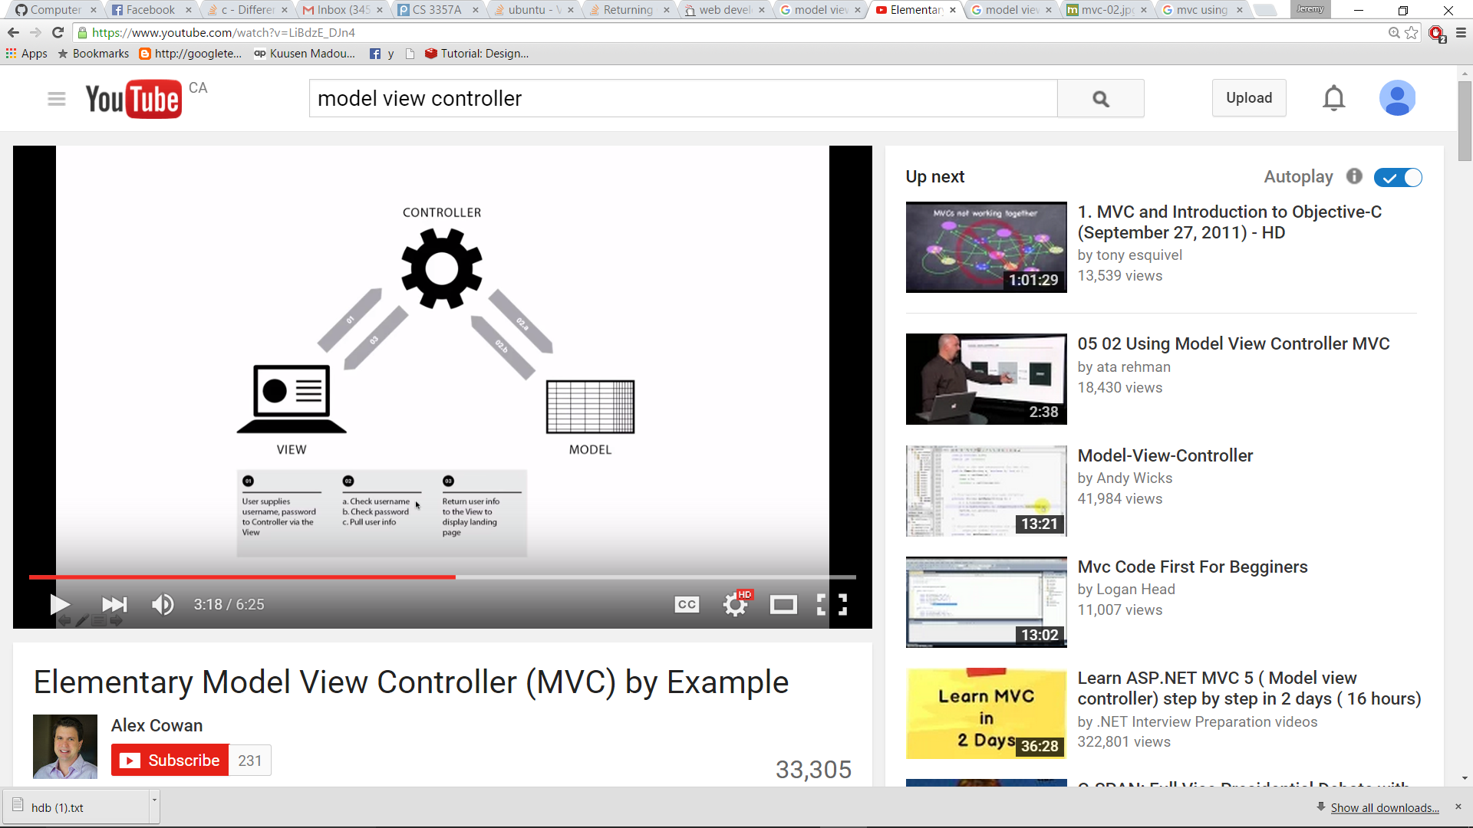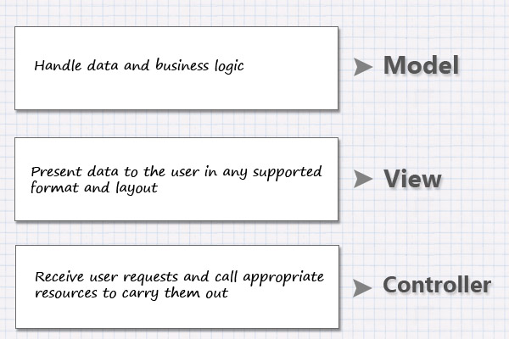

*Also see our UML for reference*

Our program is implemented using the Model-View-Controller (MVC) design pattern. Shown above.

The reason for choosing this pattern is due to it being simple to implement as well as its ability to encapsulate the various layers in our program.

Referencing the picture above:

**View:** consists of classes that use QT to create our GUI. The layout of the program is based upon the model class. mainwindow is a part of this.

The model consists of two parts: Business Logic and Model

**Model:** In this portion of the design, we take the information from excel csv and store them into memory. Then we use the data stored in the memory to build object models. An example would be *Professor* class.

**Business Logic:** Here, we write code logic that can manipulate the data. An example of this would be the *errorHandling* class, which checks whether the dates are valid.

**Controller:** Also named the *controller* class. The controller puts together the entire software. The controller builds the view and model objects as well as call their functions.

**An example of the dataflow of the program would be as follow:**

User input-> category: teachers, type: pie chart, teaching hours: 10

->Controller: Get the user input, call the methods in the business logic

->Model: call the business logic methods -> access the Model classes -> access the excel spreadsheet

-> Controller: obtains the information from business logic and displays it back onto the view

->View: display the information